Crafting an inclusive activity planner for persons with Down syndrome

Damir Pozderac1, Nejla Bečirspahić1, Dženis Muhić1, Šeila Bećirović Ramić1, Irfan Prazina1, Lejla Kafedžić2, Vensada Okanović1

Faculty of Electrical Engineering, University of Sarajevo1

Faculty of Philosophy, University of Sarajevo2

Sarajevo, Bosnia and Herzegovina

[dpozderac1@etf.unsa.ba](mailto:dpozderac1@etf.unsa.ba), [nbecirspah1@etf.unsa.ba](mailto:nbecirspah1@etf.unsa.ba), [dmuhic1@etf.unsa.ba](mailto:dmuhic1@etf.unsa.ba), [sbecirovic1@etf.unsa.ba](mailto:sbecirovic1@etf.unsa.ba), [iprazina1@etf.unsa.ba](mailto:iprazina1@etf.unsa.ba), [lejla.kafedzic@ff.unsa.ba](mailto:lejla.kafedzic@ff.unsa.ba), vokanovic@etf.unsa.ba

Abstract—The applications presented in this conference paper focus on the development of a mobile and web application serving as a planner with a focus on tracking persons with Down syndrome. These innovative technological solutions contribute to the development of independence and functionality for persons with Down syndrome while emphasizing the importance of inclusivity in society. In addition to focusing on organizing activities, the mobile and web applications provide support and facilitate daily tasks. The web application allows parents/guardians/teachers to add new activities to the planner and track the progress of these activities. On the other hand, the mobile application enables persons with Down syndrome to record their activities within the application, considering their specific challenges, and customizing the user interface to their needs.

*Keywords-activity planner; mobile application; web application; Down syndrome*

# Introduction

In the modern era of digital technology, technological advancements can positively impact an individual's quality of life in various ways. The planner presented in this conference paper is precisely such an example, i.e., an example of the application of technology in supporting persons with Down syndrome. Down syndrome, also known as Trisomy 21, is a genetic disorder that occurs when a person has an extra copy of chromosome 21 [1]. Persons with Down syndrome may exhibit varying levels of intellectual development. However, with tailored support and training, these persons can achieve diverse degrees of independence and functionality. When it comes to supporting persons with Down syndrome, one of the key approaches is to provide them with a higher level of independence in their daily lives. Society is increasingly aware of the importance of inclusivity and support for persons with Down syndrome who enrich our world with their goodwill, authenticity, and positive outlook. By developing applications tailored to persons with Down syndrome, we create an environment where they feel supported, valued, and included.

Ultimately, the implementation of such a system for organizing activities and tracking assigned tasks not only provides a solid foundation and necessary support to teachers and caregivers but also inspires them to unwaveringly dedicate themselves to common goals. Apart from its purely technological application, this initiative represents a powerful driver that motivates teachers and caregivers to reach the full potential of persons with Down syndrome.

# State of the art

There are several applications focused on activity planning. Unfortunately, only a few are for individuals with Down syndrome. One of the earliest applications is iPrompts [2], which was developed for people with intellectual disabilities. It is a support tool for creating and presenting visual schedules, timers, and choices. It allows picture sequences with detailed step-by-step explanations of what to do. The application is currently not available.

Vizuelni Raspored [3] is a web application developed by ICT-AAC that provides support by showing the timeline of required activities and a step-by-step explanation with pictures. Primary users are children.

Thruday [4] is an AI-powered paid mobile application. It is a visual daily planner application for people on the spectrum and caregivers.

Goally tablet [5] is a paid tablet with an application for children that is used to create routines with custom steps with pictures and videos.

# research framework

## Development tools

The development of the user interface of the web application utilized by React [6] is recognized as a powerful tool in the field of front-end development. React stands out for its significant contribution to facilitating the creation of interactive user interfaces. Based on key principles of modularity and code reusability, React emerges as an essential development platform closely linked to an innovative approach to software development based on the concept of components [7]. These characteristics ensure development agility, operational efficiency, and a high level of flexibility. Furthermore, React's key advantage lies in its ability to integrate with diverse ecosystems, enabling developers to optimize the performance and functionality of their applications.

React Native, an evolution of React, based on the ReactJS JavaScript library, successfully combines the advantages of this popular JavaScript framework with a focus on mobile platforms [8]. React Native enables the development of mobile applications using JavaScript, offering developers efficiency and simplicity in creating high-quality user interfaces. With its ability to share code across different platforms, React Native represents a powerful tool. The previously mentioned advantage of React Native over other development tools is enabled by its use of native components and APIs for interacting with hardware and the operating system, resulting in high performance and behavior similar to native applications.

Node.js represents an asynchronous execution environment for JavaScript, focused on events, specifically designed for building scalable network applications [9]. Node.js was used to run the web server and maintain constant communication with the device's operating system. Node.js, despite its simple architecture, can handle multiple tasks simultaneously without blocking the main program flow, contributing to high efficiency in working with complex web applications. Additionally, a minimalist web framework connected to Node.js, Express, has been utilized to facilitate the construction of server-side components of the application [10], particularly enabling the creation of APIs for communication between mobile and web applications.

PostgreSQL [11] has been used for data storage and management. It stands out for its reliability, security, and flexibility. The architecture of this database allows for efficient data manipulation, ensuring data integrity. Its ability to support complex queries and transactions makes it an ideal choice for applications requiring high performance and reliable data management.

The use of Node.js, React, React Native, and PostgreSQL in the development of mobile and web applications provides a harmonious blend of performance, modularity, and efficiency. Express and NPM [12] further enrich the experience, facilitating dependency management, building server components, and enabling efficient communication between mobile and web applications. This technological combination creates a robust framework that ensures optimal user experience, data integrity, and efficient resource management.

## Concepts

The mobile and web applications have been carefully designed to meet the specific needs of persons with Down syndrome. With set goals, the application aims to provide significant support to this community on several key fronts. Additionally, the application emphasizes visual and audio support, offering the option to add images and voice recordings to tasks to facilitate understanding. These features are intended to further facilitate users in tracking and completing tasks, promoting not only independence but also a clearer understanding of daily responsibilities. The idea of visually representing tasks stems from the fact that persons with Down syndrome have a highly developed visual perception. Furthermore, the application emphasizes visual and audio support, offering the option to add images and voice recordings to tasks to facilitate understanding. Visual support is included because persons with Down syndrome often exhibit strong visual perception while simultaneously facing challenges in reading text. Understanding that each person has unique preferences, including preferences for receiving information, the option of voice messages has been implemented to provide additional support to users. These features are intended to further facilitate users in tracking and completing tasks, promoting not only independence but also a clearer understanding of daily responsibilities. Through this application, we aim to create a tool that not only simplifies users' lives but also builds bridges towards broader social inclusion, emphasizing the importance of support and understanding for this special community.

## Implementation

The web application for planning and tracking the activities of a child with Down syndrome provides a range of benefits to parents/guardians/teachers, significantly easing and enhancing their daily care for the child. Convenience and accessibility are key aspects of this application. The ability to access information online allows parents/guardians/teachers to easily view the activity schedule, whether they are at home, at work, or even while traveling. This is particularly useful when parents are away from the child or when a quick check of the schedule or any changes in the plan is needed. Using React for the front end and Node.js for the back end has achieved a high level of integration and coherence in the functioning of the entire application. Through carefully designed user experience, the goal was to simplify the organization of daily tasks and responsibilities of parents regarding their children. Furthermore, systematic efforts were made to create an interface that supports different devices and screens, ensuring a consistent and pleasant experience regardless of how the application is accessed. Moreover, special attention has been given to accessibility to ensure that users with different needs can easily use the application. Integrated techniques that facilitate access to content and interaction include appropriate color contrasts, clear labels, and intuitive controls. The aim was to create an application that is functional and inclusive.

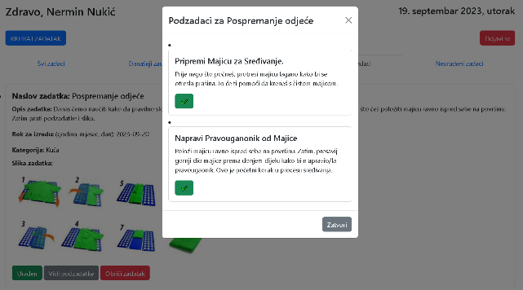

1. Web application display

On the planner, there is a button for creating a task, which upon clicking opens a form for task definition. Additionally, there is a button on the right side that, upon clicking, logs the user out of the application and redirects them to the login screen. The central part of the planner represents the space where tasks created by the user will be displayed. There are five lists or sections where tasks can be displayed, depending on the data defined in the form (if a task is marked as important during creation, it will be inserted into the Important Tasks list). All created tasks will be inserted into the "All Tasks" list. In addition to the "Important Tasks" and "All Tasks" lists, there are also lists for completed and uncompleted tasks, as well as a list for today's tasks.

Upon accessing the planner or refreshing the page, the user will be notified whether their child is currently using their mobile application. In Figure 2, the situation is presented when the child is using the mobile application, and the parent is notified.

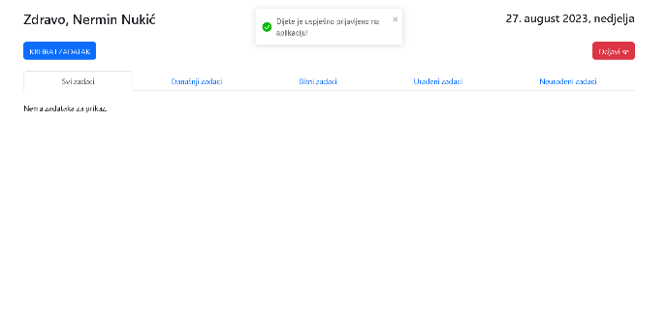

1. Planner with the notification that the child is using the mobile application

When the "Create Task" button is clicked, the corresponding form opens. This window provides numerous options for customizing the task according to the user's needs. We notice the option to mark the task as important, where the user can highlight the task's significance. Additionally, the user must enter the task name, add subtasks, and assign descriptions to them. Additionally, there is an option to attach an image to tasks and select task categories (home, school, hygiene). The user must define a deadline for task completion. The method for setting the deadline is illustrated in Figure 3.

The task image is uploaded by completing the upload of the image selected by the user from their computer. There is validation of entered and selected data, so if any data is not entered, a warning is displayed. In the task creation form, there is also a button "Add Subtasks" which, when clicked, opens a new window. For one task, it is possible to define a maximum of 10 subtasks. When the button to add a subtask is clicked, the subtask will be successfully saved, and the form will be refreshed.

This structured approach to task creation with subtasks is carefully designed to facilitate tracking and completing various tasks for individuals with Down syndrome. The primary goal of this division is to enable these individuals to better monitor their progress and successfully accomplish tasks assigned to them. Through such adapted organization, individuals with Down syndrome are provided with the opportunity to engage gradually in smaller steps within each task, aiding in their comprehension of processes and achievements of each segment. This approach also contributes to increased independence and self-confidence, as they can more clearly see their progress and accomplishments, making challenges achievable and attainable. Through a carefully structured hierarchy, this method supports individuals with Down syndrome in reaching their potentials and feeling successful in their everyday tasks.

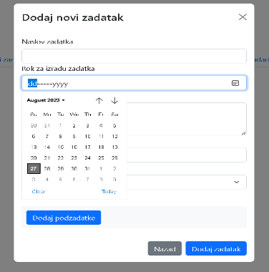

1. Setting the deadline for task completion

When all subtasks are added, the user should click on the gray button to finish creating the subtasks, and the user returns to the original task creation form. When all data and fields have passed validation and when the user clicks the button to add the task, it is added to the planner as shown in Figure 4:

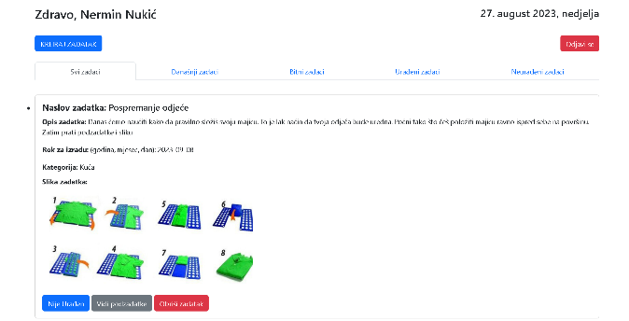

1. Display of the created task in thr planner

The created task is inserted at the beginning of the "All Tasks" section, "Uncompleted Tasks" section, and "Important Tasks" section if it is marked as important in the task creation form. It also appears in the "Today's Tasks" section if the user has selected an appropriate date for that situation. The task in the list is represented by a card with segments defining key attributes for the task. At the bottom of the card, there is a gray button that, when clicked, opens a window displaying a list of all subtasks for the selected task. At the bottom of the card, there is a gray button that, when clicked, opens a window displaying the list of all subtasks for the selected task. Next to the button for displaying subtasks on the left side, there is a label closely associated with the subtasks in such a way that if at least one subtask for the observed task is marked as incomplete, the label will read "Not done." If all subtasks are marked as completed, then the observed segment will be labeled as "Done."

When a task is marked as completed, it is automatically removed from the "Uncompleted Tasks" list and added to the "Completed Tasks" list.

The user has the option to delete any task whenever they deem it necessary. For this purpose, each card representing a specific task is associated with a "Delete Task" button, which, when clicked, opens a confirmation window for deleting the task.

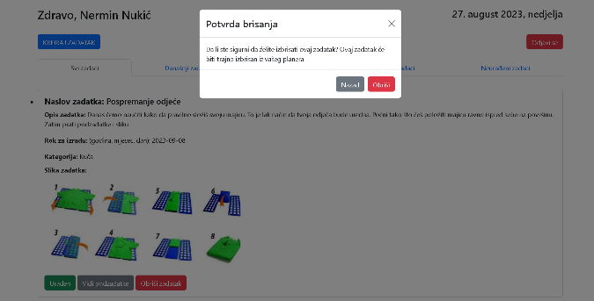

1. Confirmation of task deletion

The mobile application has been developed to meet the specific needs of individuals with Down syndrome. The user experience begins with an intuitive home screen, providing users with the option to select their status – parent or child. Logging into the user account through a user-friendly interface allows quick access to the user account. Notably, for individuals with Down syndrome, the login process requires entering a four-digit number, facilitating a simpler and more accessible way for their authentication.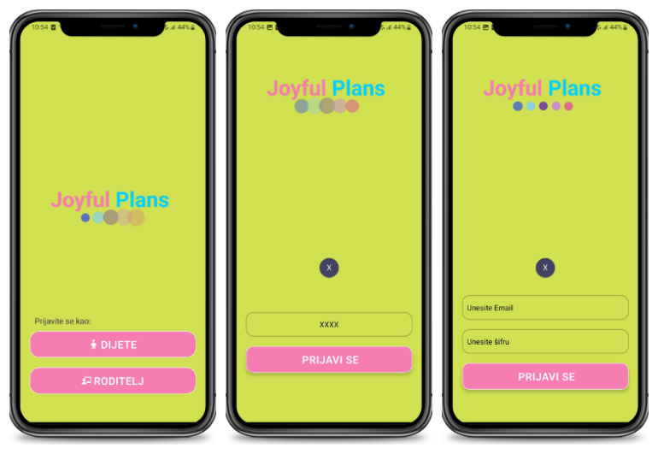

1. User login

After successfully logging into their user accounts, whether they are parents or children, users are greeted by the same home screen. This screen provides an overview of all pending tasks, offering users insights into their upcoming responsibilities.

At the top of this screen, there is an icon corresponding to the current time of day, whether it's "morning," "day," or "night."

Depending on the time of day, users receive a personalized greeting, such as:

* "Good morning, [user's name]!"
* "Good day, [user's name]!"
* "Good evening, [user's name]!"

This personalized greeting aims to create a warm welcome, fostering a friendly atmosphere at the beginning of their interaction with the application.

To provide users with a better understanding of their upcoming tasks, a prominently highlighted section draws attention to the number of pending tasks. Users can filter pending tasks based on their preferred time frame, with options including:

* Today: Displaying tasks scheduled for the current day, facilitating a quick overview of daily responsibilities.
* Week: Showing tasks planned for the current week, aiding in tracking weekly obligations.
* All: Displaying all tasks regardless of the time frame, offering a comprehensive view of upcoming responsibilities.

By default, the application shows all tasks added by parents, but users can utilize these filtering options for better organization and time management.

Tasks are divided into two sections: "Important Tasks" and "Tasks." Important tasks are presented on larger cards for visual emphasis, with a horizontal layout for easy navigation. Tasks of standard priority are displayed on smaller cards in a vertical layout. Tasks are categorized into "School," "Hygiene," and "Home," each represented by a specific color and icon, facilitating quick recognition and organization.

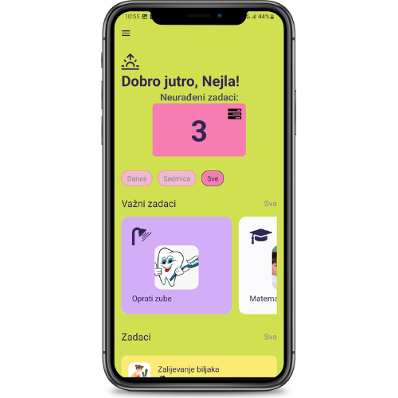

1. Task overview

When the user clicks on a task, a screen with the title, execution date, and task image is displayed. Clicking on the image triggers an animation that rotates the image by 180°, revealing the task description. If the user wants to view the image again, they can easily achieve this by clicking again on the task description. If a parent adds a voice recording, there is an icon available to play it. The screen also includes subtasks, where unfinished subtasks appear as gray cards. The user can horizontally swipe to navigate through the list of subtasks. This intuitive interface enables users to thoroughly explore each task and track progress through the subtask list.

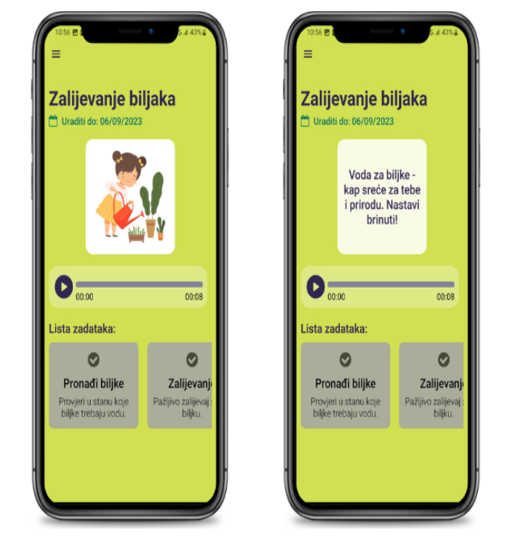

1. Task details display

When a child successfully completes a specific subtask, they simply need to click on the corresponding subtask card. This action opens a modal window, as shown in Figure 9 (left), providing a visual representation of the progress for that specific task. The subtask card changes its color to white after completion, serving as a clear visual indication of completed subtasks and those that are pending. It's important to note that when the card turns white, clicking on it will not open a new modal window, indicating that the subtask has already been successfully completed.

The overview and tracking of subtask status are illustrated in Figure 9 (right), clearly distinguishing between completed and uncompleted tasks. It's crucial to mention that this option is disabled for parents, meaning they can only review which subtasks have been completed and which are still pending. In other words, after a parent clicks on a card, there will be no change, as this option is not available to them.

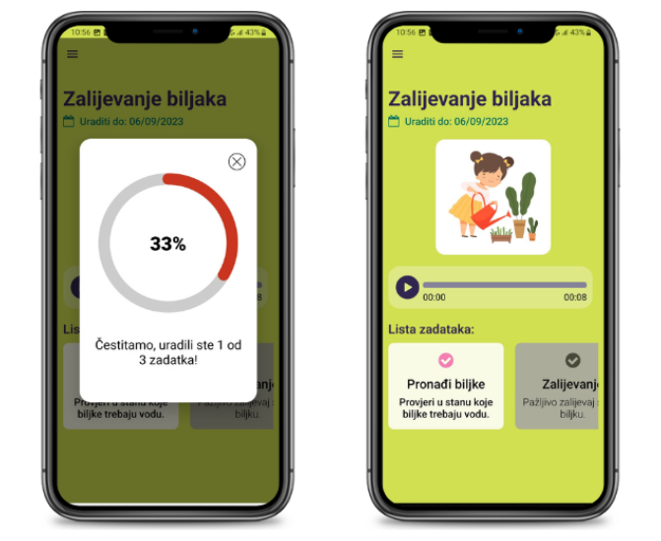

1. Subtask execution

After successfully completing a task, it is moved to the 'Completed Tasks' section. The distinction between completed and uncompleted tasks brings several benefits for individuals with Down syndrome:

* Clear and simple structure facilitates tracking and understanding of obligations.
* Displaying completed tasks provides a sense of achievement, encouraging autonomy in task management.
* Reducing anxiety by separating tasks into completed and uncompleted helps manage stress.

In the mobile application the 'Completed Tasks' screen looks the same as the 'Uncompleted Tasks' screen. This organization provides individuals with Down syndrome an effective way to manage tasks, promotes productivity, and instills a sense of security in daily activities.

Figure 10 depicts the section for creating new tasks, available only to parents. To create a task, the user must enter mandatory information such as title, attaching an image, description, deadline, and at least one subtask. Additionally, selecting a category and marking the task as 'important' are optional. If any of the mandatory data is missing, the user will receive an Alert notification. Adding audio recordings is optional, but the user can include a recording as desired.

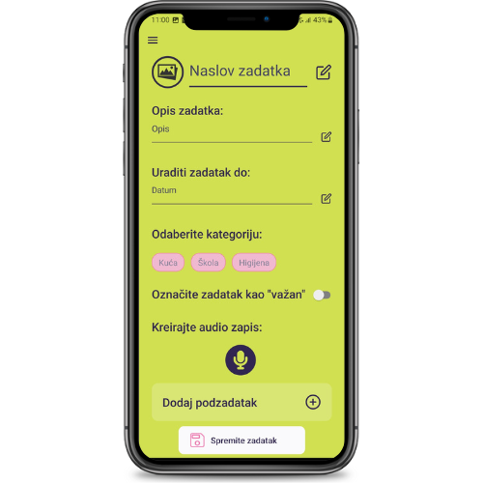

1. Appearance of the 'Add Task' section

The user can utilize the option to record audio, with the process illustrated in Figure 11. Recording is initiated by clicking the 'microphone' icon, and after recording, the user can review and re-record the audio.

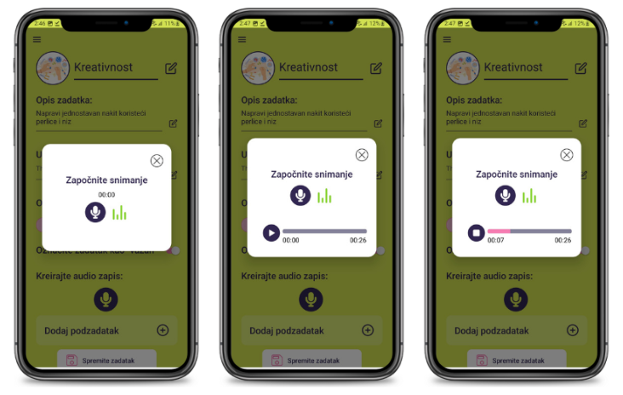

1. Creating audio recordings

When the user wants to add a subtask, they need to enter the subtask title and description, then click 'Save'. Each added subtask is displayed in the list, allowing the user to review and edit subtasks whenever necessary. This functionality provides users with flexibility in organizing and managing their tasks.

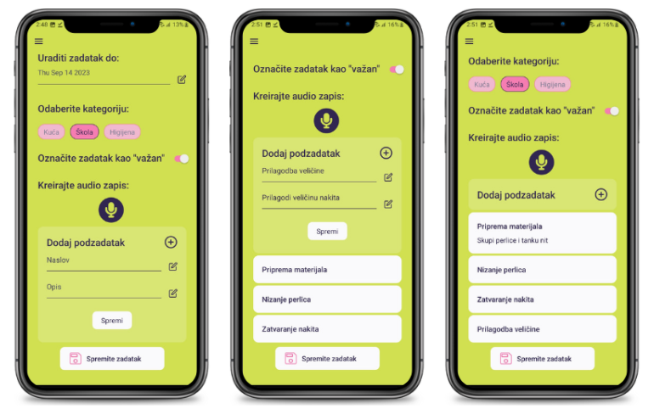

1. Creating subtasks

After entering all the necessary data for the task, the user clicks 'Save Task,' and an Alert appears to confirm the successful addition of the task. The child can then begin executing the task, while the parent monitors progress through the mobile application.

Navigation within the mentioned sections, whether the user is a parent or a child, is managed through the DrawerNavigator, a navigation component in the React Navigation library. The DrawerNavigator allows the display of a navigation menu on the left side of the screen, commonly used in mobile applications for quick access to various sections. Within the DrawerNavigator, the user can set or change their profile picture by clicking on the circular area or using the text "Change profile picture" for personalized account customization. The option to log out of the user account is also available within the DrawerNavigator for a secure exit from the application.

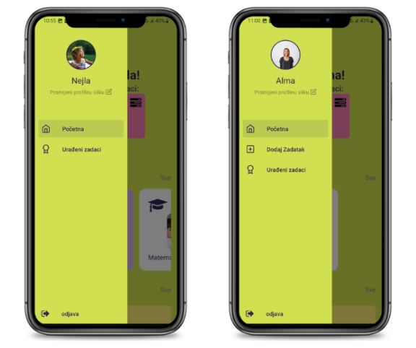

1. Navigation through sections

## Results Interpretation

The web and mobile applications enable tracking the progress of persons with Down syndrome in various activities over time. This provides parents, caregivers, and teachers with insights into what works best for the child, allowing for adjustments and changes in the plan to achieve optimal development. Enhanced communication is a key component of these applications, facilitating easy communication among parents, caregivers, and therapists via the app, exchanging progress information, schedule changes, or other relevant details. This improves collaboration and coordination among all involved parties, creating a supportive environment for the child's development. Moreover, existing planners are often not tailored to the specific needs of persons with Down syndrome. Therefore, the development team has implemented a web and mobile application with special features designed to facilitate usage and adapt to the individual abilities of the users. Most digital planners are not intuitive enough for persons with special needs, making the design of a simple and understandable interface crucial to enhancing the user experience for persons with Down syndrome. One solution to this issue is the development of a digital planner with visual cues, such as images, symbols, or colors, aimed at facilitating task comprehension and tracking. Additionally, one of the key advantages of digital planners is their availability on various devices, including computers, tablets, and smartphones, enabling users to access information easily wherever they are. However, it is important to consider certain drawbacks of such solutions. The use of technology requires access to computers or smartphones, which may be a barrier for some parents, especially those with less experience or access to technology. Concerns about the privacy and security of sensitive data can also raise worries, as online data storage carries certain risks. Also, regular updates to the application are important for maintaining functionality, but they may require additional time and effort.

It is important to note that the web application is not a substitute for real interaction, especially in therapies that require the physical presence of a therapist or instructor. Adapting to the child's specific needs can also be challenging, as some therapies or activities may not be fully compatible with the application, requiring additional solutions or approaches. The web and mobile applications for planning and tracking activities for persons with Down syndrome provide numerous advantages that facilitate the daily lives of parents and caregivers. Still, it is important to carefully consider how this support aligns with other available forms of assistance, taking into account individual needs and preferences.

# conclusion

In summary, this paper presents two applications aimed at improving the lives of persons with Down syndrome and their families. These applications offer user-friendly interfaces, visualization, and valuable support, all of which are significant for persons with Down syndrome. What sets these applications apart is their foundation in a deep understanding of the key characteristics of persons with Down syndrome. As a result, these applications pave the way for persons with Down syndrome to integrate into society and become more independent in their daily activities, ultimately leading to an improved quality of life. With great enthusiasm and optimism, we expect the results of this research to significantly contribute to a deeper understanding and practical application of web applications as support for parents facing such challenges. The key to success lies in a continuous process of adaptation and improvement, where the application will serve as a foundation for future development steps. Ultimately, these applications not only offer a solution to current challenges but also provide a platform that will evolve to meet future needs and contribute to a better life for families caring for children with Down syndrome.

REFERENCES

|  |  |
| --- | --- |
| [1] | L. Postolache, A. Monier and S. Lhoir, "Neuro-Ophthalmological Manifestations in Children with Down Syndrome: Current Perspectives," *Eye and Brain,* vol. 13, pp. 193-203, 2021. |
| [2] | S. Riley, "iPrompts® PRO," [Online]. Available: https://www.educationalappstore.com/app/iprompts-pro.  [Accessed 29 01 2024]. |
| [3] | "Vizualni raspored," [Online]. Available: http://usluge.ict-aac.hr/vizualni-raspored/. [Accessed 29 01 2024]. |
| [4] | "Visual Planning App for Autism, ADHD, ADD, Neurodiversity," Thruday, [Online]. Available: https://thruday.com/.  [Accessed 29 01 2024]. |
| [5] | "Goally," [Online]. Available: https://getgoally.com/.  [Accessed 29 01 2024]. |
| [6] | A. M. Vipul and P. Sonpatki, ReactJS by Example-Building Modern Web Applications with React, Packt Publishing Ltd, 2016. |
| [7] | A. Banerjee, "ReactJS Functional Components - GeeksforGeeks," GeeksforGeeks, Sanchhaya Education Private Limited, [Online]. Available: https://www.geeksforgeeks.org/reactjs-functional-components/. [Accessed 13 01 2024]. |
| [8] | A. Boduch, React and react native, Packt Publishing Ltd, 2017. |
| [9] | O. Foundation, "About Node.js," [Online]. Available: https://nodejs.org/en/about. [Accessed 13 01 2024]. |
| [10] | "Node.js - Express Framework," [Online]. Available: https://www.tutorialspoint.com/nodejs/nodejs_express_framework.htm. [Accessed 13 01 2024]. |
| [11] | T. P. G. D. Group, "PostgreSQL: The world's most advanced open source database," [Online]. Available: https://www.postgresql.org/. [Accessed 13 01 2024]. |
| [12] | n. Inc., "npm," [Online]. Available: https://www.npmjs.com/. [Accessed 13 01 2024]. |